**[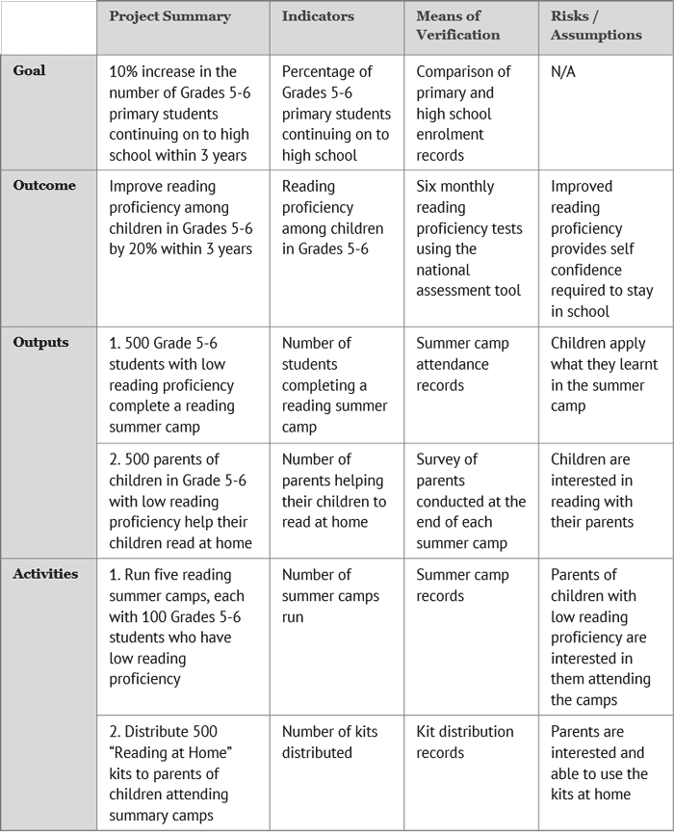](http://www.tools4dev.org/wp-content/uploads/Indicators-and-means-of-verification.png)Logical Framework Example**